WORKSHOP: Optimizing PPC campaign

In this project, your team will serve as a paid search (PPC) consultant for a small ethnic and tribal jewelry store. The firm's e-commerce sales manager currently uses Google Ads to attract customers to the site. While she is generally satisfied with the current PPC performance, she believes there is room for improvement. Your task is to provide recommendations that will help the store increase revenue while staying within their existing advertising budget.

PART I: PERFORMANCE ANALYSIS OF THE CURRENT CAMPAIGN

- Calculate the following metrics for each Ad Group for the provided data. (Note that the dataset represents a 12-month period.)

Metric | Formula
Number of Keywords | COUNT(DISTINCT keyword)
Impressions | SUM(Impressions)
Clicks (traffic) | SUM(Clicks)
Total Costs | SUM (costs)
Number of Items Sold | SUM (units_sold)
Revenue | SUM (revenue)
Net Revenue | Revenue – Total Costs
Earnings per Click | Revenue / Clicks
Return on Ad $ Spent (ROA) | Net Revenue / Total Costs

< INSERT YOUR AD GROUP LEVEL SUMMARY TABLE HERE>
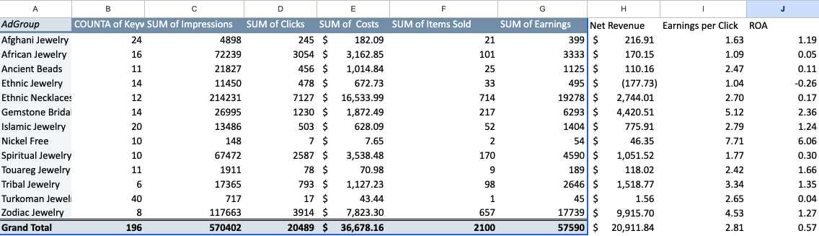

- Identify the ad group which has the lowest ROA and the lowest Net Revenue: Ethnic Jewelry

- Assume that this Ad Group is dropped from future campaigns. Dropping an unprofitable ad group releases funds that can be reallocated to other ad groups. How much money will become available to the manager to spend elsewhere? $672.73

PART II: EXPANDING A WELL-PERFORMING AD GROUP

- Identify the best performing ad group in the current campaign: Gemstone Bridal
HINT: Select the ad group that has the highest ROA AND has generated at least 50 units in sales.

- What are the Earnings per Click for this ad group? $5.12

- List the top 3 keywords in this ad group in terms of Net Revenue per keyword generated:
- Sapphire wedding bands: $1,863.55 ($2,668 earnings - $804.45 costs)
- Emerald and diamond wedding set: $1,599.20 ($2,349 earnings - $749.80 costs)
- Morganite wedding set: $509.70 ($696 earnings - $186.30 costs)

- Copy and paste the top three performing keywords identified in the previous step into Google Keyword Planner and ask for new keyword ideas (i.e. click on “Discover new keywords”)
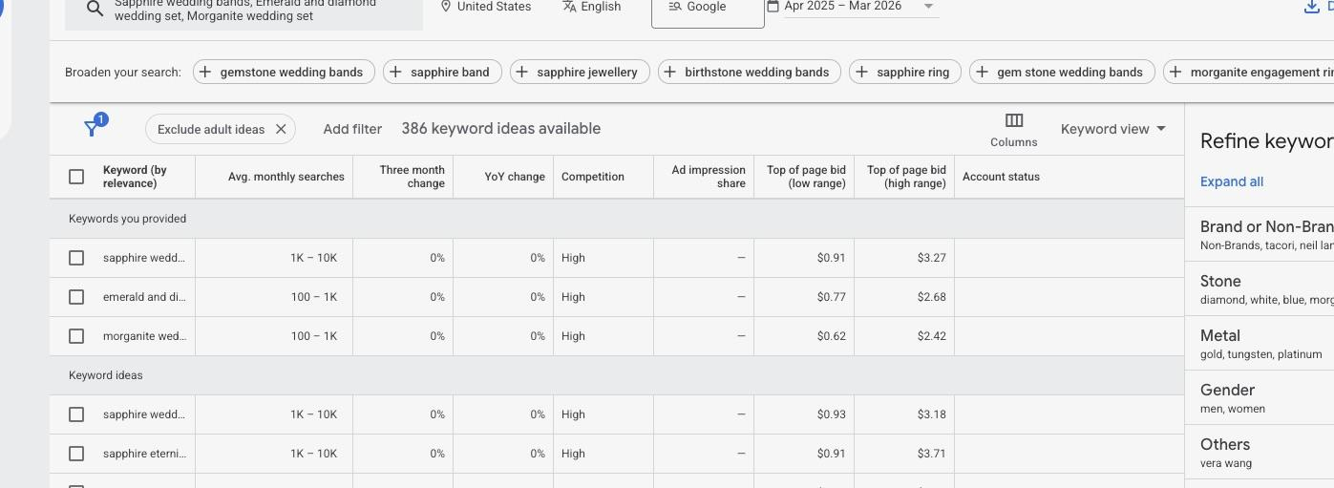
- Under “Keyword plan” tab, scroll down to the “Keyword ideas” table. (Do NOT use the keywords shown in “Keywords you provided” section!)

- Propose ONE NEW keyword to be added to this ad group and perform Net Revenue calculations. NOTE: You may need to repeat the following steps multiple times or try additional “seed” keywords in Step 4 that are semantically related to the Ad Group you are expanding to find a good keyword:

- Select a keyword from the “Keyword ideas” section that has a high number of monthly searches and add it to your plan (click on “ADD KEYWORD”).

- Switch to “Forecast” tab

- set the bid strategy to “Manual CPC“
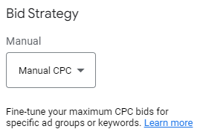
- set targeting to “All Locations”, “All languages”, delivery to “Google and search partners”, and time frame to “All time”:

- expand Forecast panel (“Your plan can get…”) by clicking on .

- Try different values of Bid amount (i.e., max CPC) to find the bid that maximizes your Net Revenue for this keyword.

Hints:
- It might be helpful to set up a separate worksheet where you compute the resulting Net Revenue as a function of your proposed Bid amount. E.g.,

Bid Amount (Max.CPC) | Clicks | Avg.CPC | Total Costs | Revenue* | Net Revenue
set by you | From google keyword planner | From google keyword planner | Calculated by you | Calculated by you | Calculated by you
* To calculate Revenue, assume that the proposed keyword has the same earning-per-click as the Ad Group that you are expanding (see step Part II.2). Therefore, earning could be calculated as: Predicted Clicks x earnings-per-click

- Note that for a keyword to stay profitable your resulting Avg. CPC should not exceed earnings-per-click.

- Note that as you increase your Bid Amount the expected number of clicks increases too while the profit margin on each item sold decreases.

- Note that the time interval is set to “All time” which gives you 12 months forecast.

- Do not to exceed your allowed yearly budget (determined in Step 3 of Part I)

- If you are satisfied with the predicted performance of your newly proposed keyword, provide the screenshot showing forecast for your new keyword:

NEW KEYWORD: _________blue sapphire wedding band_______________

< INSERT YOUR GOOGLE KEYWORD PLANNER SCREENSHOT HERE>\
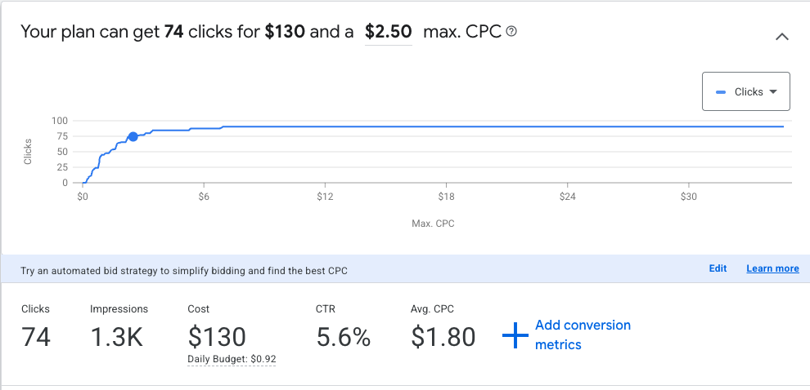

EXAMPLE:

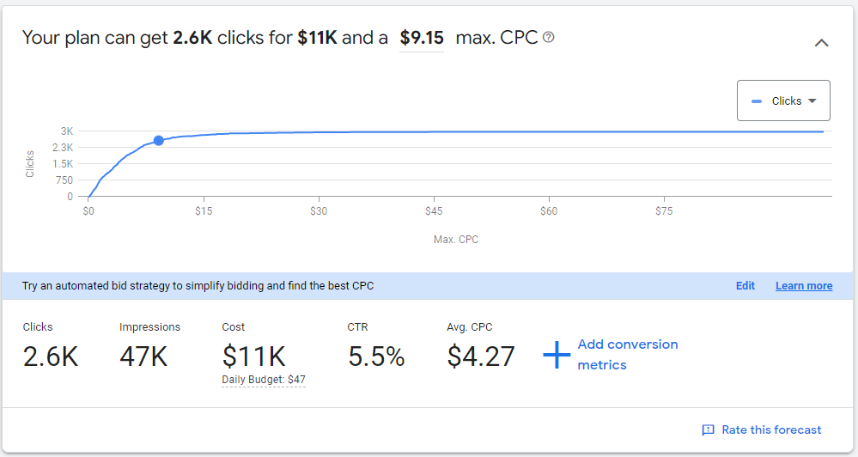

- report your results in the table below, otherwise repeat the steps (a) through (c) above by trying another keyword. Note that the fields “Proposed Keyword”, “Max.CPC”, “Clicks”, and “Avg. CPC” should match the numbers from your screenshot.

Proposed Keyword | Bid Amount (Max.CPC) | Clicks | Avg.CPC | Total Costs | Revenue | Net Revenue
Blue sapphire wedding band | $2.5 | 74 | $1,8 | $130 | $378.88 | $248.88

PART III: SUMMARY

Summarize your overall revenue implications as follows:

BEFORE: Total Net Revenue (across all ad groups) before the proposed improvements (based on Part I, Step 1): $20,911.84

AFTER: Total Net Revenue assuming the unprofitable ad group is dropped (i.e., you don’t spend your budget on that group) and the best performing ad groups expended with a new keyword (Part II, Step 6e): $$21,338.45

Any unused budget: $542.73

Submit your report on ELMS.

